Barbarian Agility Course Entry Fee! You think you got what it takes to stumble around on this agility course?! You’d be a fool to simply just walk in, you must stumble in, throw up all over the guards because you have just been tasked with doing your first…and hopefully last barcrawl!!!!! Bring a couple thousand GP, various tele methods, and an empty stomach!
- Blue moon inn! 50 gp, talk to bartender, drink the gut rot, you’re done!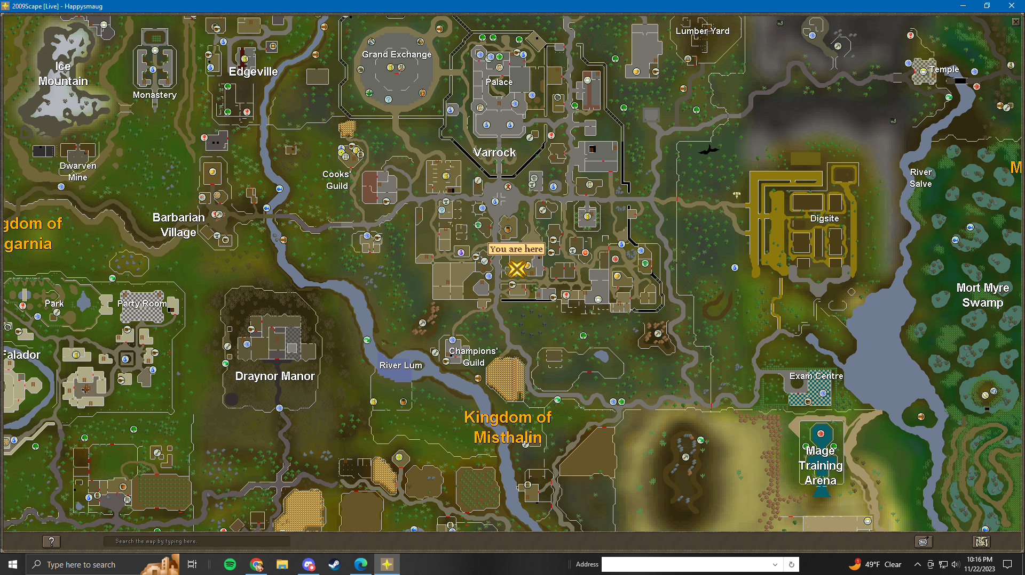
- Blueberry’s Bar, head to The Tree Gnome Stronghold! Inside the Grand Tree, 2nd floor. Use spirit tree in varrock to tele best way. Talk to the Blurberry guy, he sells you some fire toad drink for 1gp and it actually does do 1hp damage.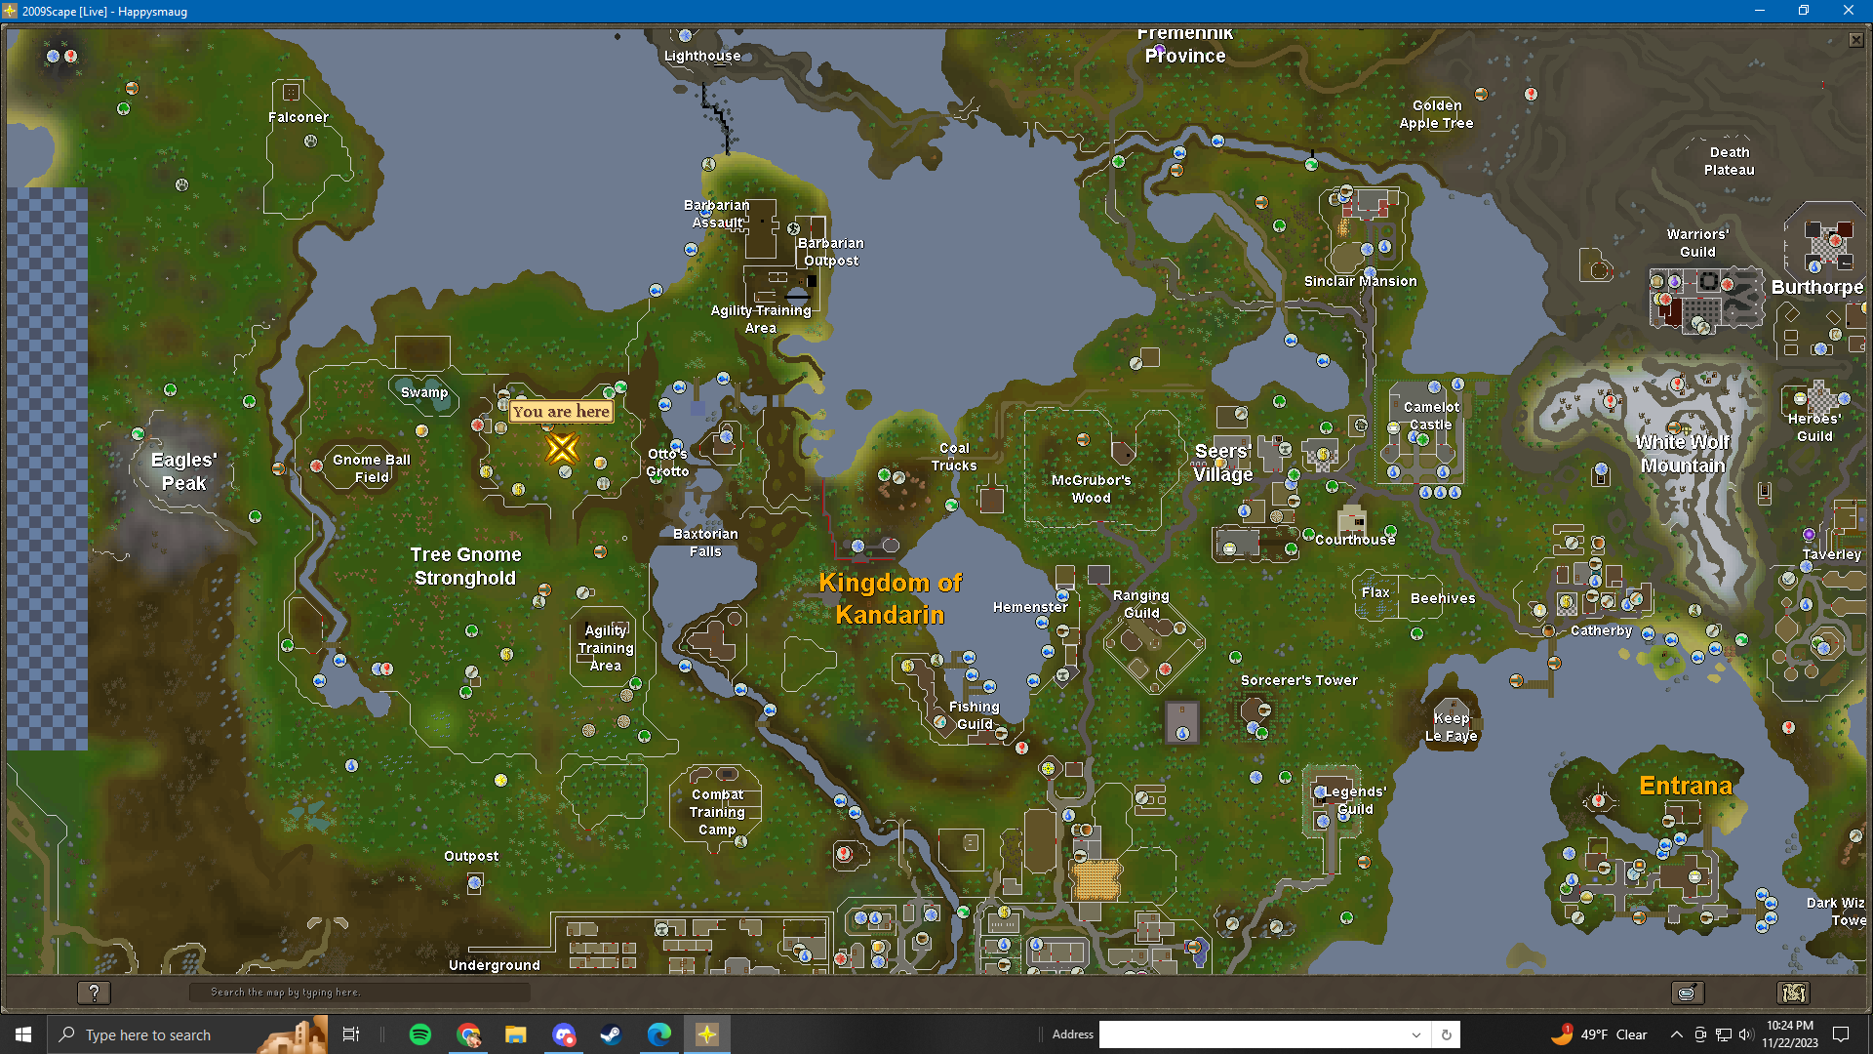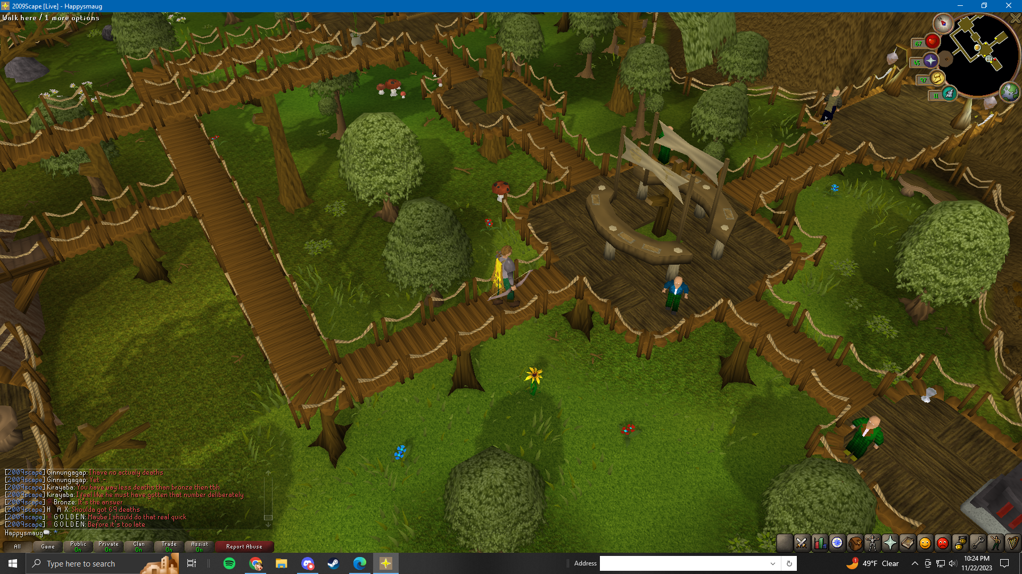
- Flying Horse Inn! Tele to Ardounge and then head to the east district and look for the bar symbol. Welcome to the smallest bar in all of 2009scape. You will have to close the door if he’s on the other side of the bar to talk to him. This one does do damage as well! It’s a heart stopper! 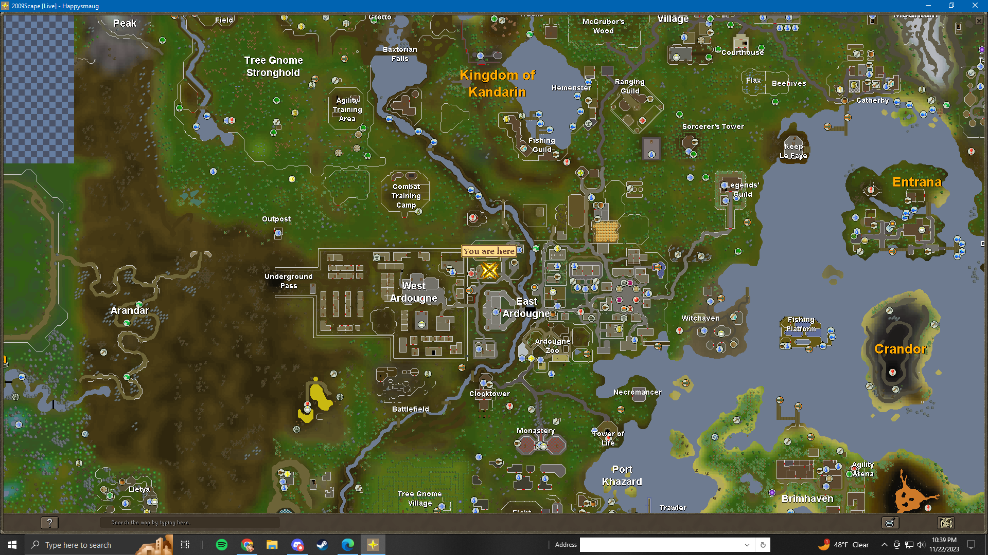
- Dead Man’s Chest Bar - Time to head to Brimhaven. I just ferried to Brimhaven. Drink the supergrog and move on..sluggishly..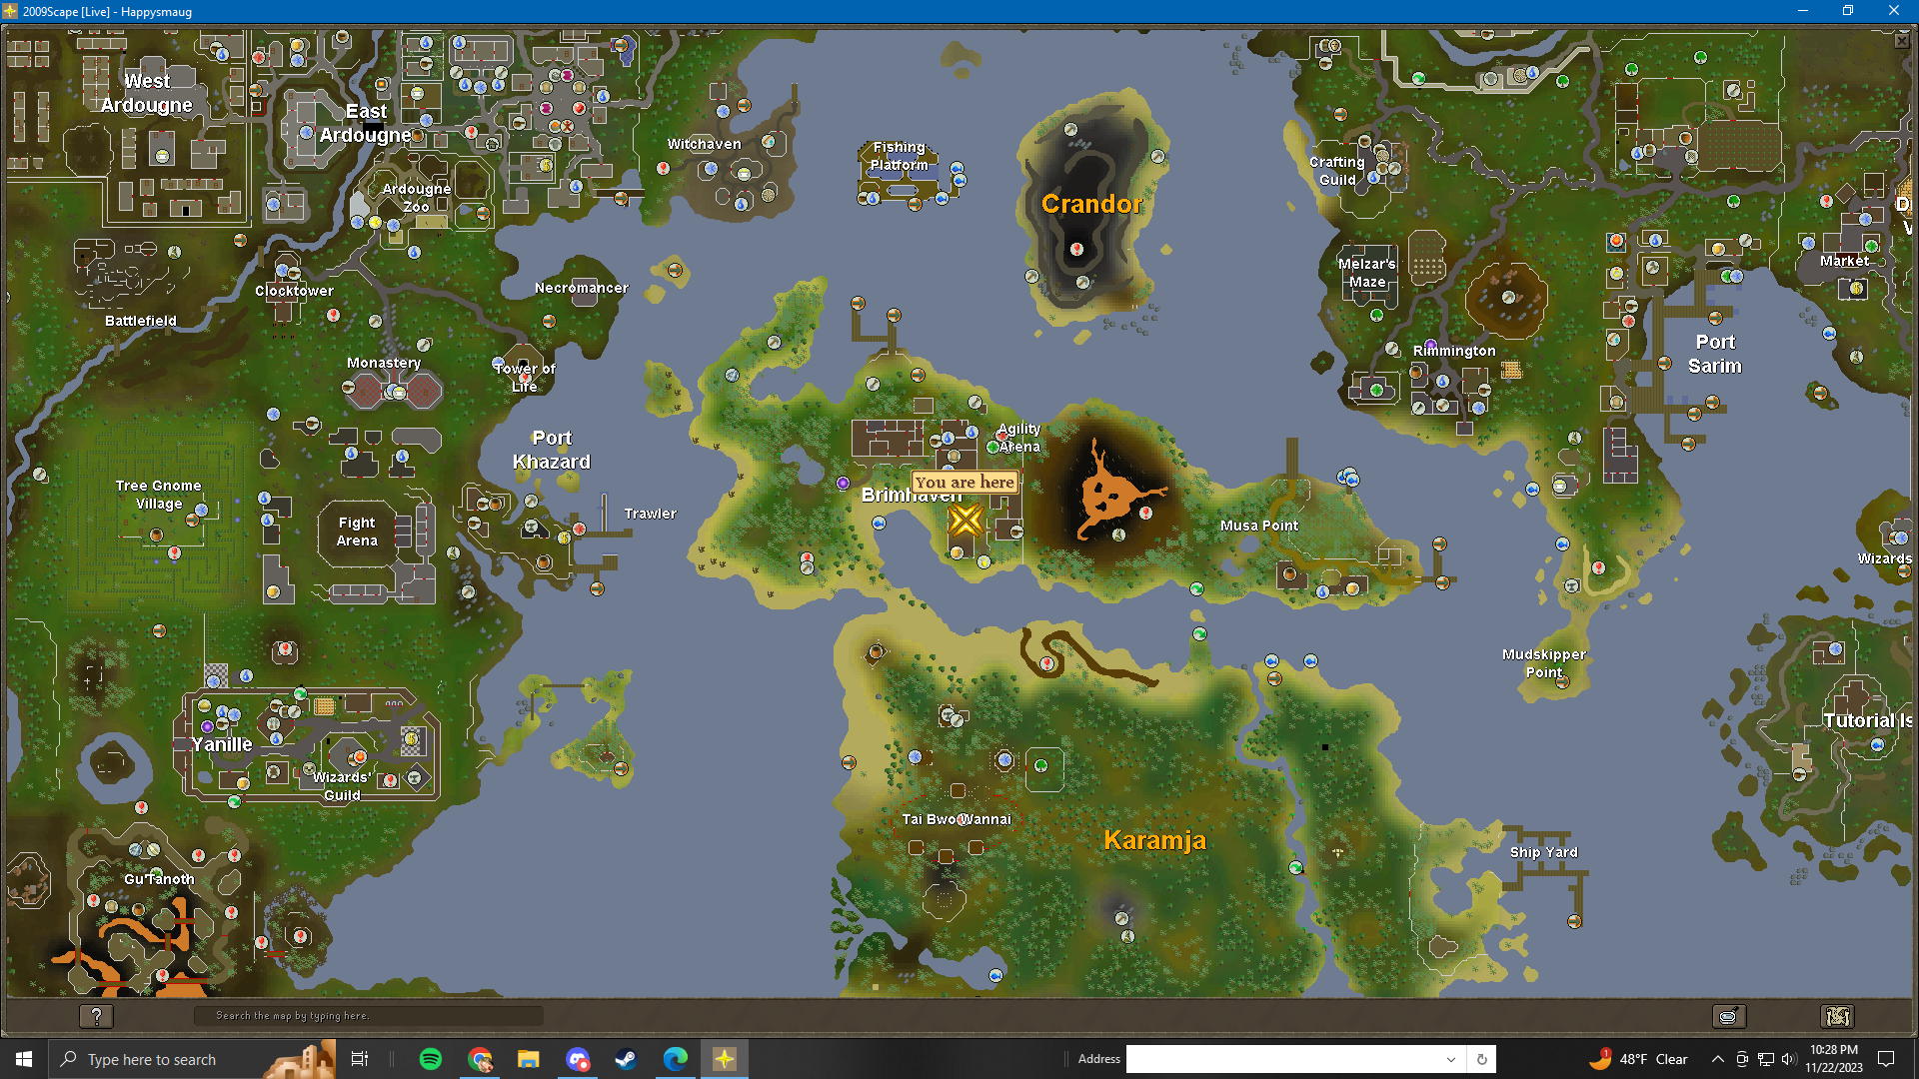
- I think it’s a good idea to just simply stroll..stumble.. over to Karamja Spirits bar, it’s just to the East by the other docks! Try some Ape Bite Liquer, you won’t even be able to spell bananas!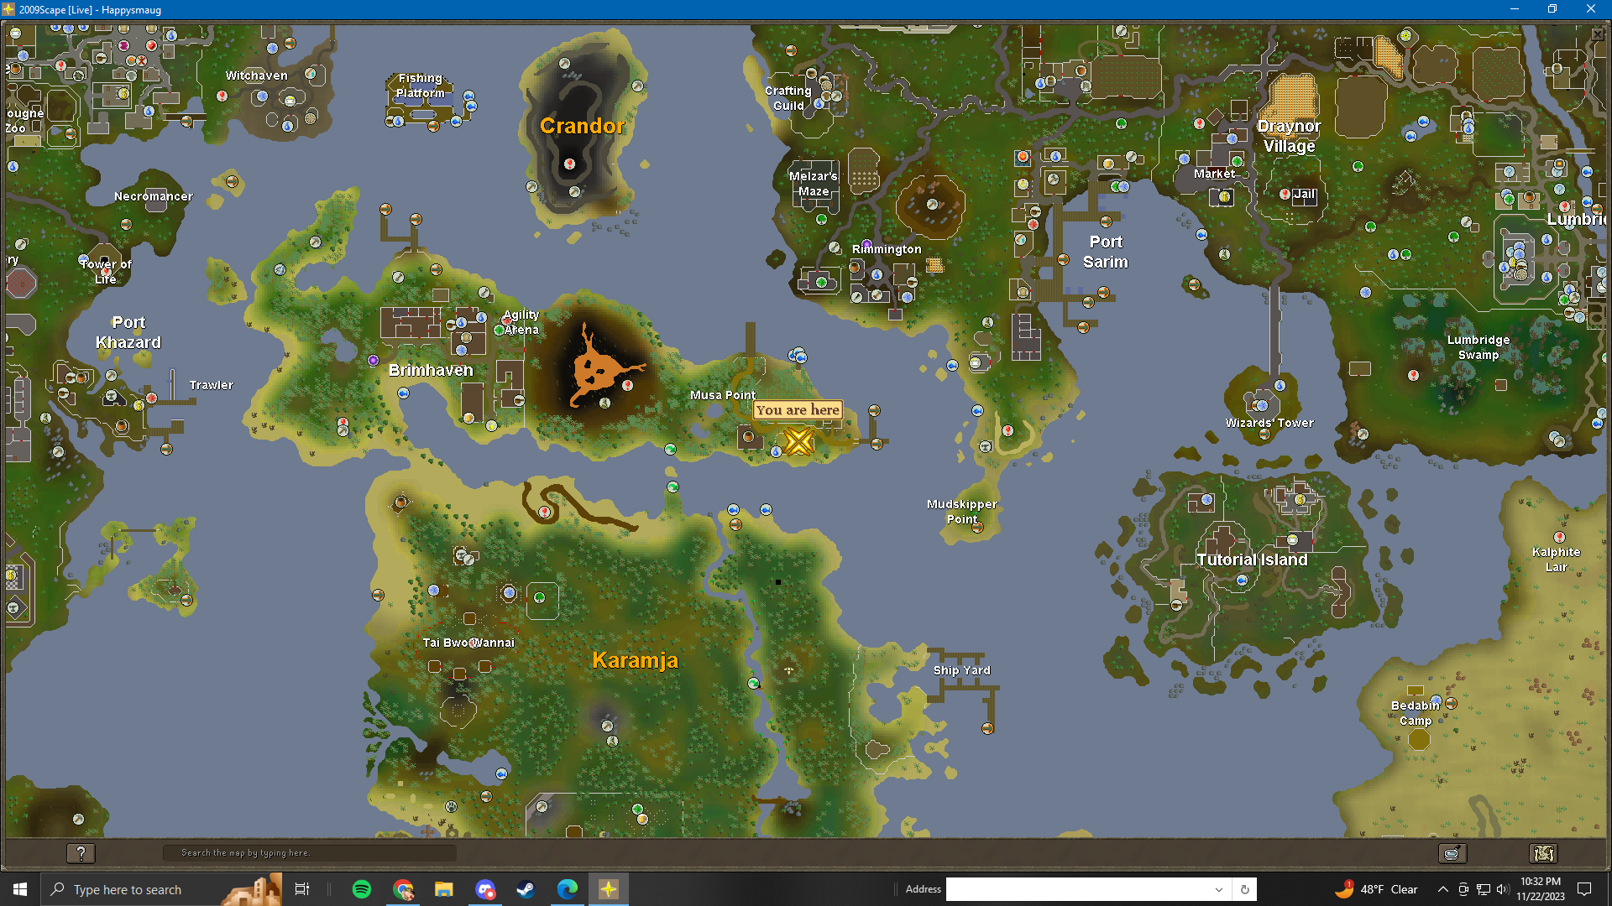
- Dragon Inn! Time to head south to Yanille. You can use fairy rings, but at this point you’re absolutely sloshed and upsetting tiny fairies with magic isn’t a good idea at this point! Use any fast travel means necessary even tele’ing back to Ardounge and running south.Drink the Fire Brandy, it’s pretty good just blurs the ole vision!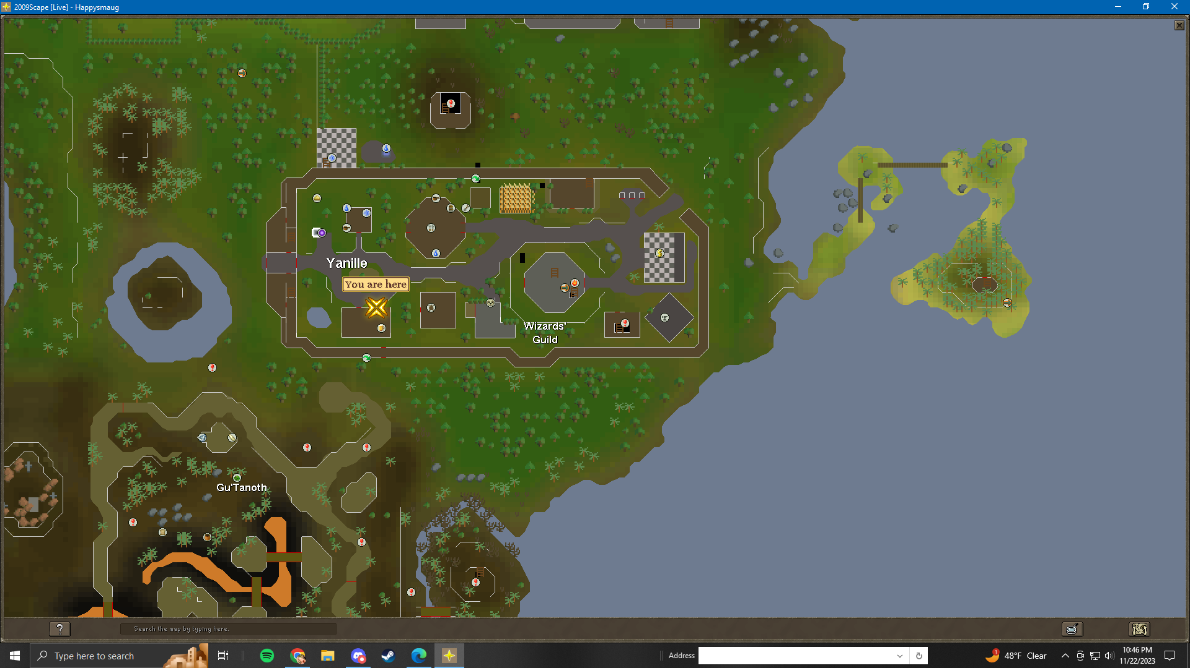
- Rising Sun Inn! Tele to Fallador and head to the bar! Try a Hand of Death cocktail and you’ll be wishing death would finally come knocking. This is going to jiggle your screen around its so powerful! It does cost 70 coins…I hope the barbarians are refunding this gp.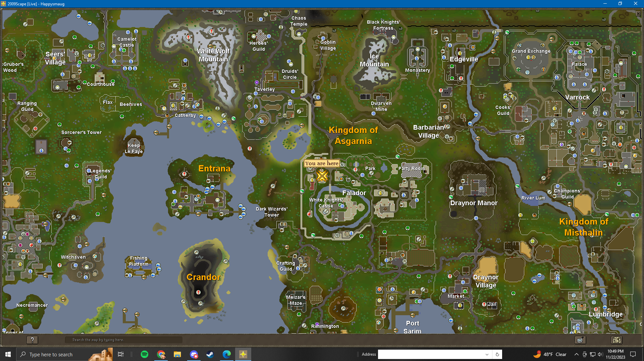
- Rusty Anchor Inn. Head directly south to Port Sarim’s bar, the Rusty Anchor! Buy a Black Skull Ale and hiccup and you’re outta there! It is 8 coins! Lots of NPC’s here just find the guy in the white apron.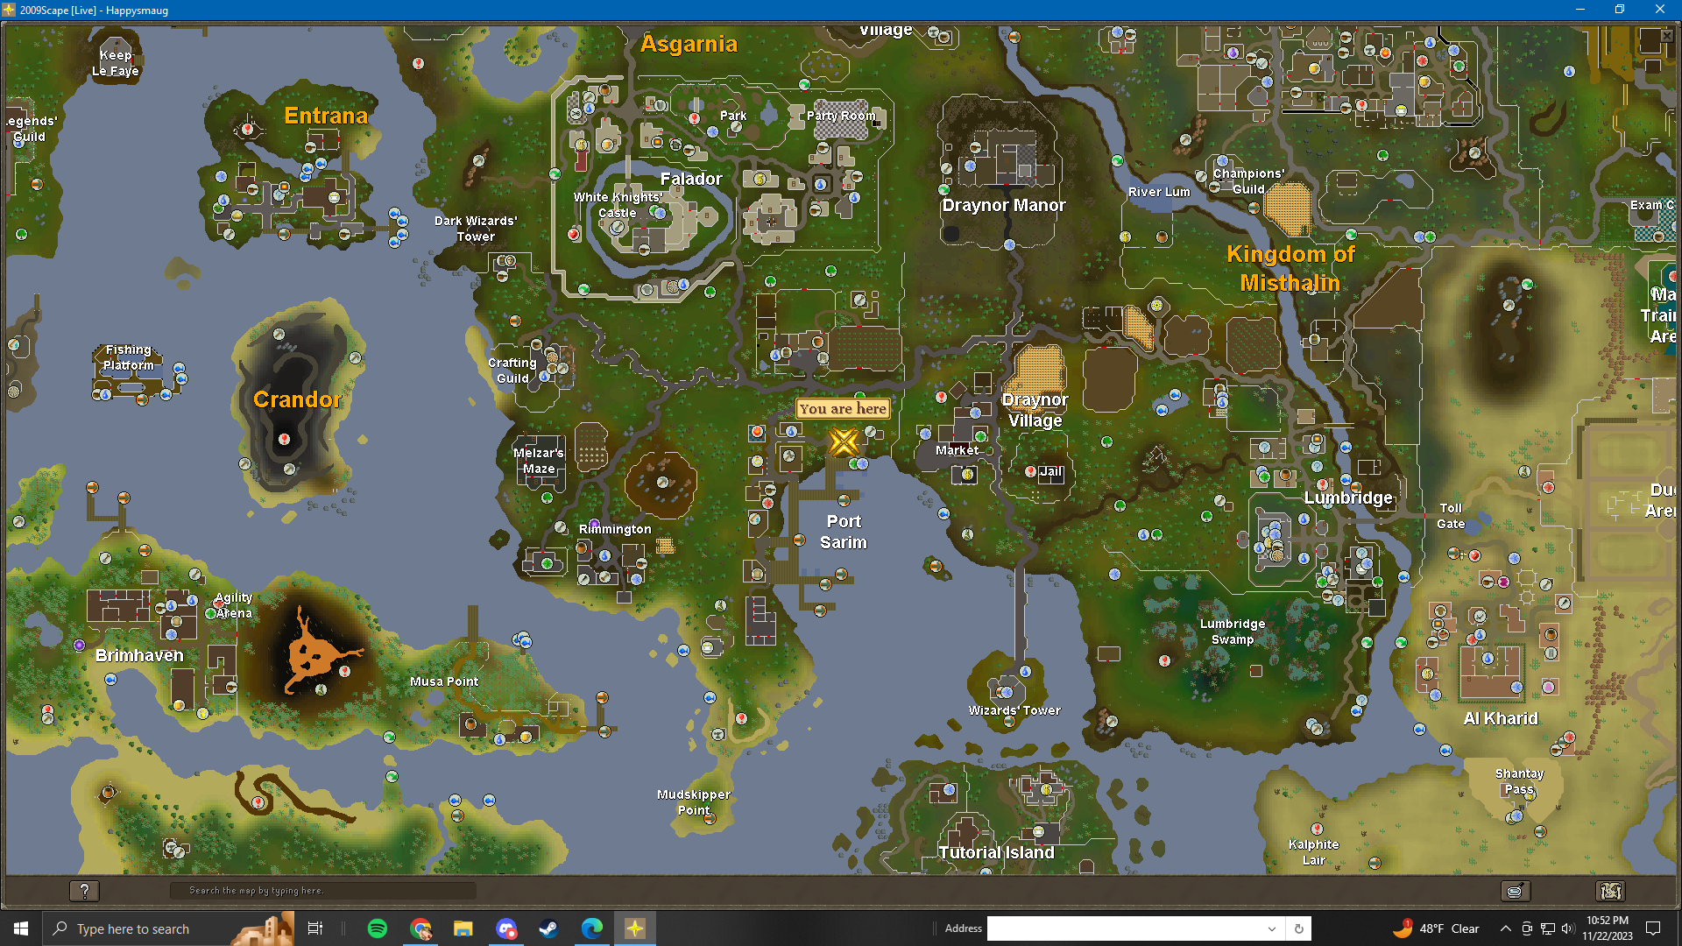
- Forester’s Arms! Head to Seer’s village via Camelot teleport or other means. Find the bar towards the West and drink this delicious Liverbane ale, trust them, your liver needs this.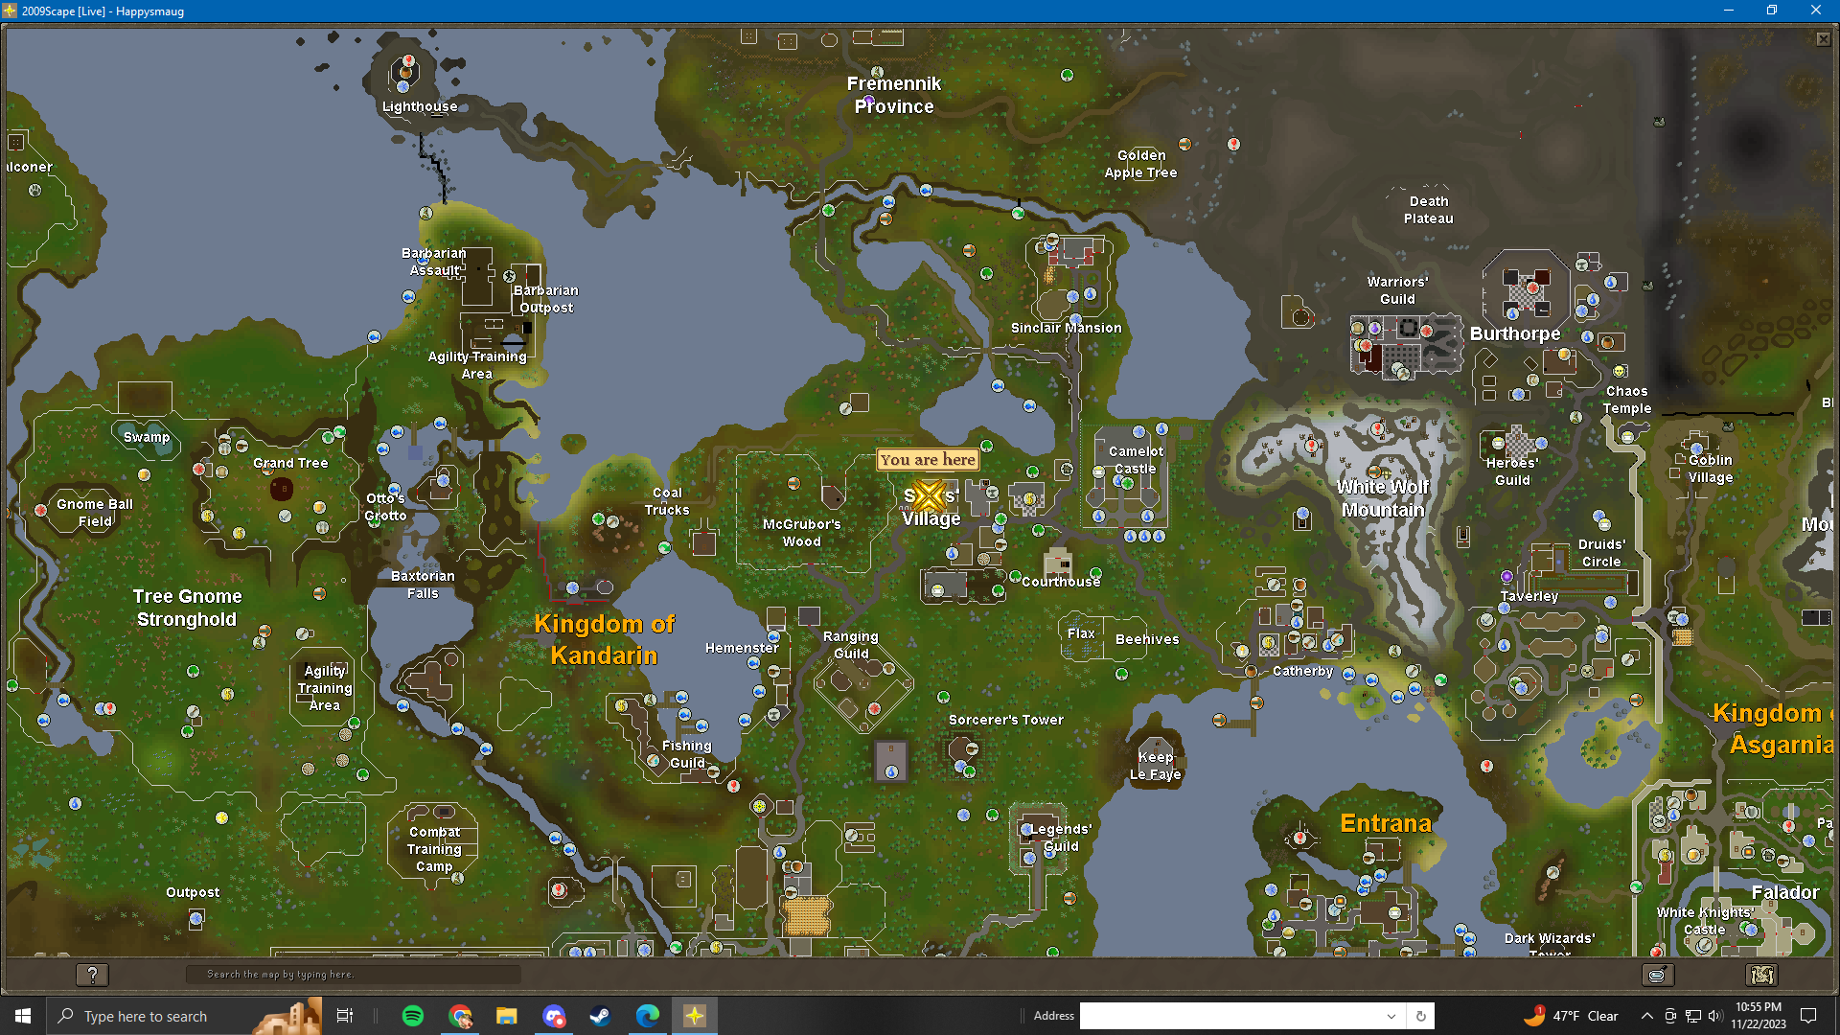
- Jolly Boar Inn - This should be familiar its the bar towards the wildy North East by the lumber yard. Take your last and final sip for this barcrawl and it’s over! 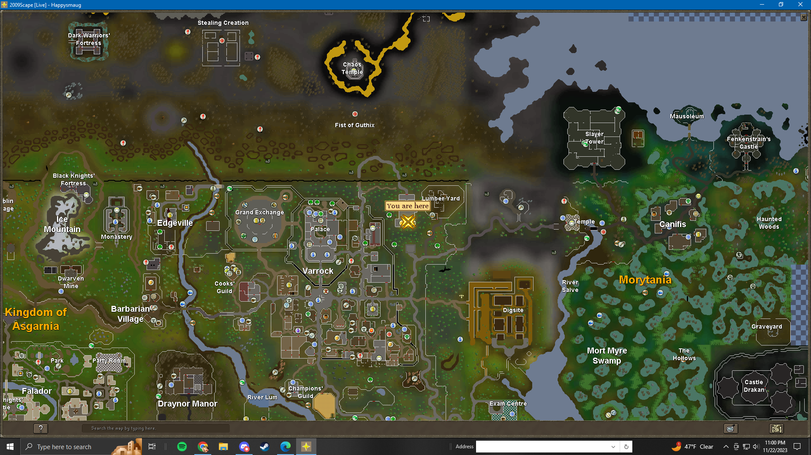
- Head back to the barbarian agility training course, definitely just use a games necklace charge and hand in the card, if you try to read what you have left to complete it will say, you are too drunk to read this card! That means you have finished all the tasks! Now you can use the agility course here in barbarian village! How neat, just don’t fall on your liver for a while.

